## **PROJECT 2**

**DAY 4/22ND AUGUST 2020**

**SUBMITTED BY:-ASHISH KUMAR SAHOO**

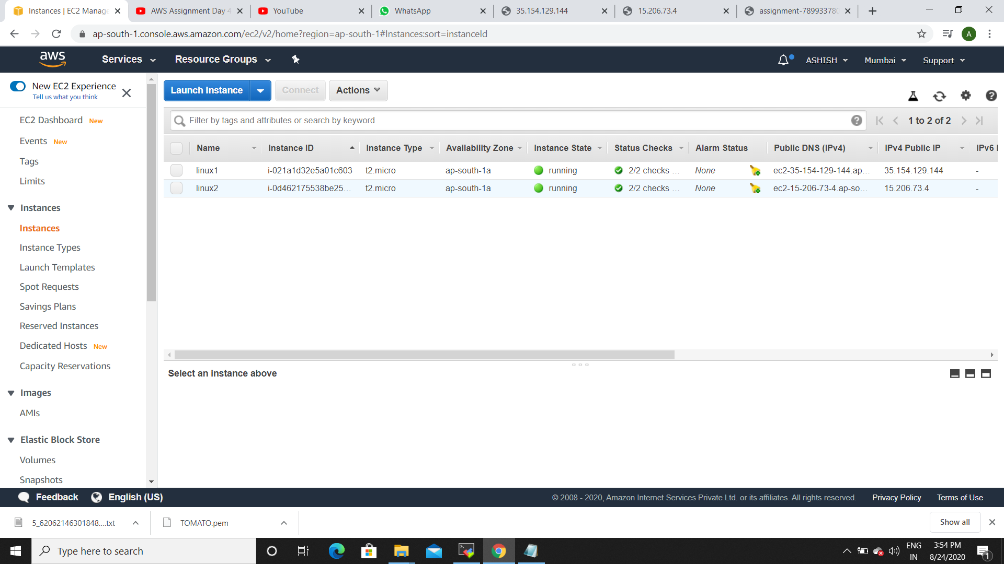

(BOTH THE INSTANCES RUNNING)

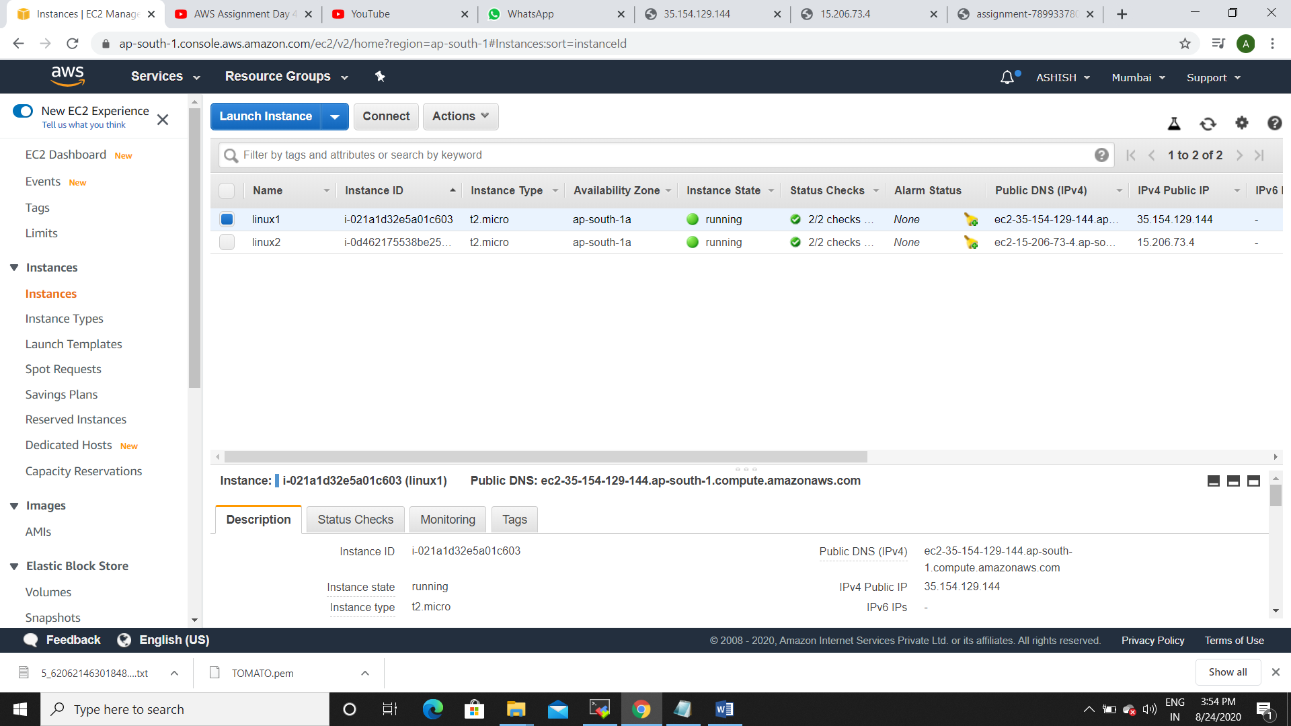

(LINUX1 WITH IP ADDRESS )

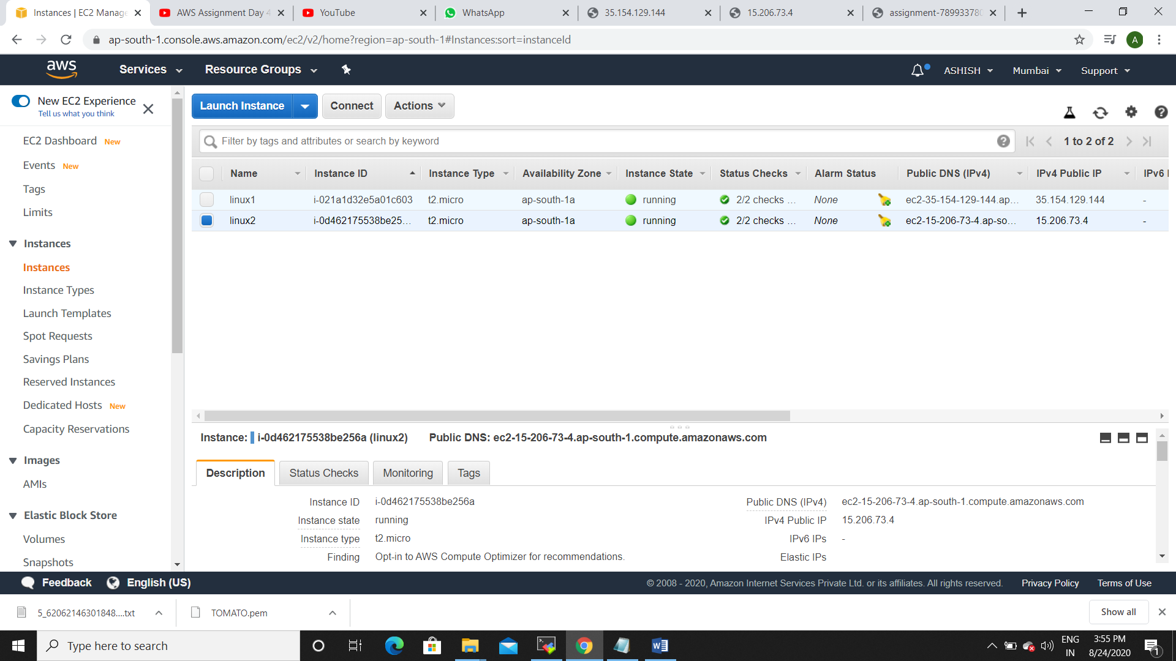

(LINUX2 WITH IP ADDRESS)

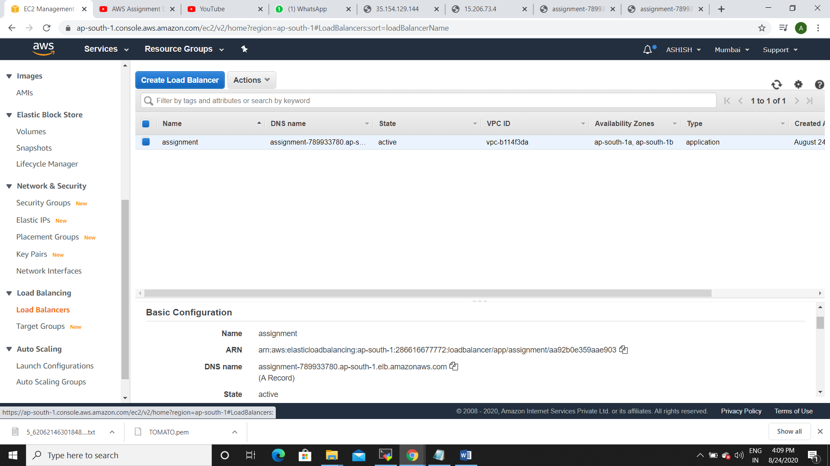

(LOAD BALANCER WHILE ACTIVE)

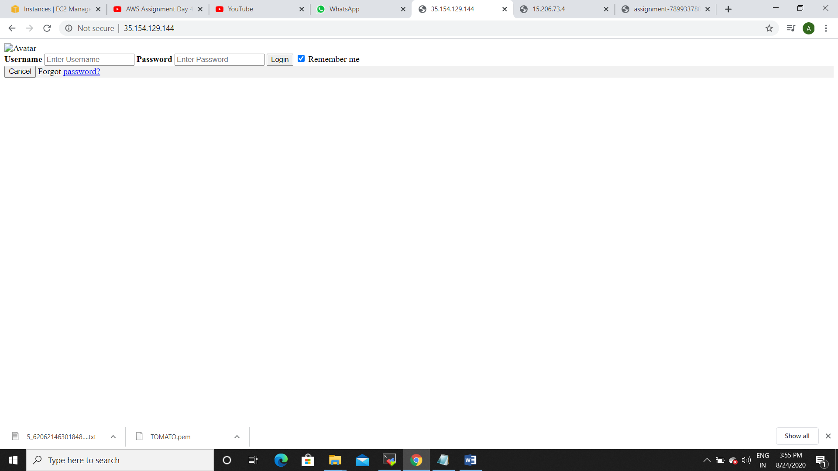

(LINUX1 HOSTED SUCCESSFULLY)

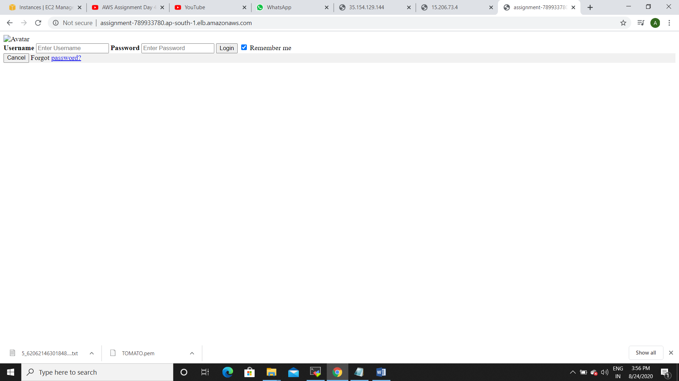

(DNS RESPONDING TO LINUX1)

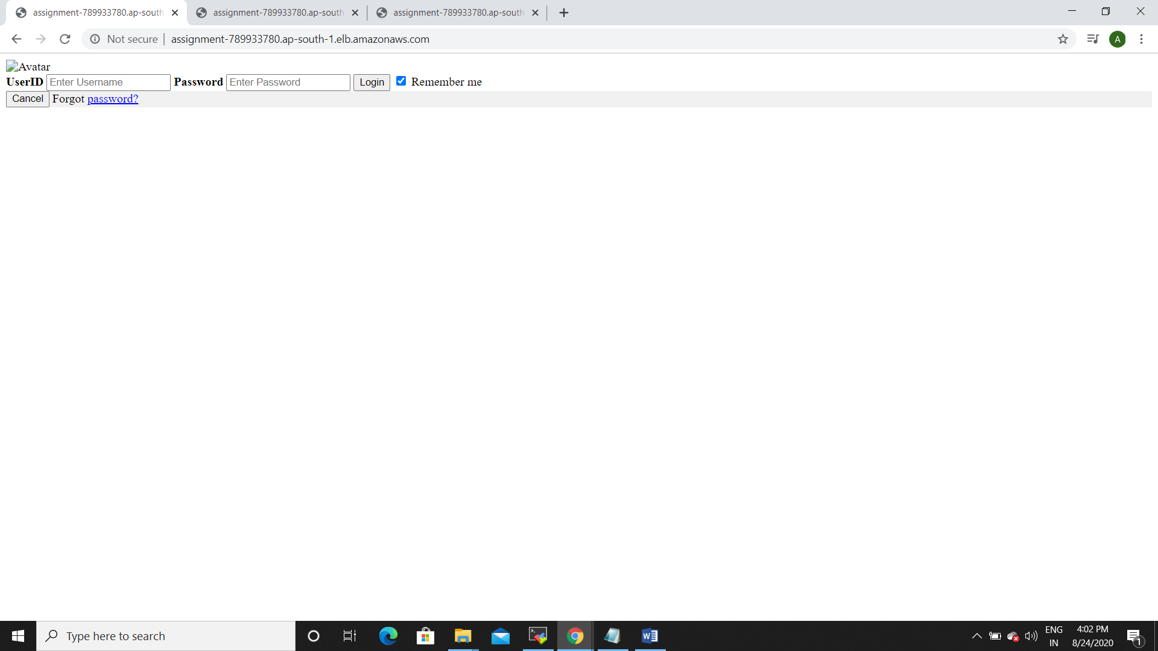

(LINUX2 HOSTED SUCCESSFULLY)

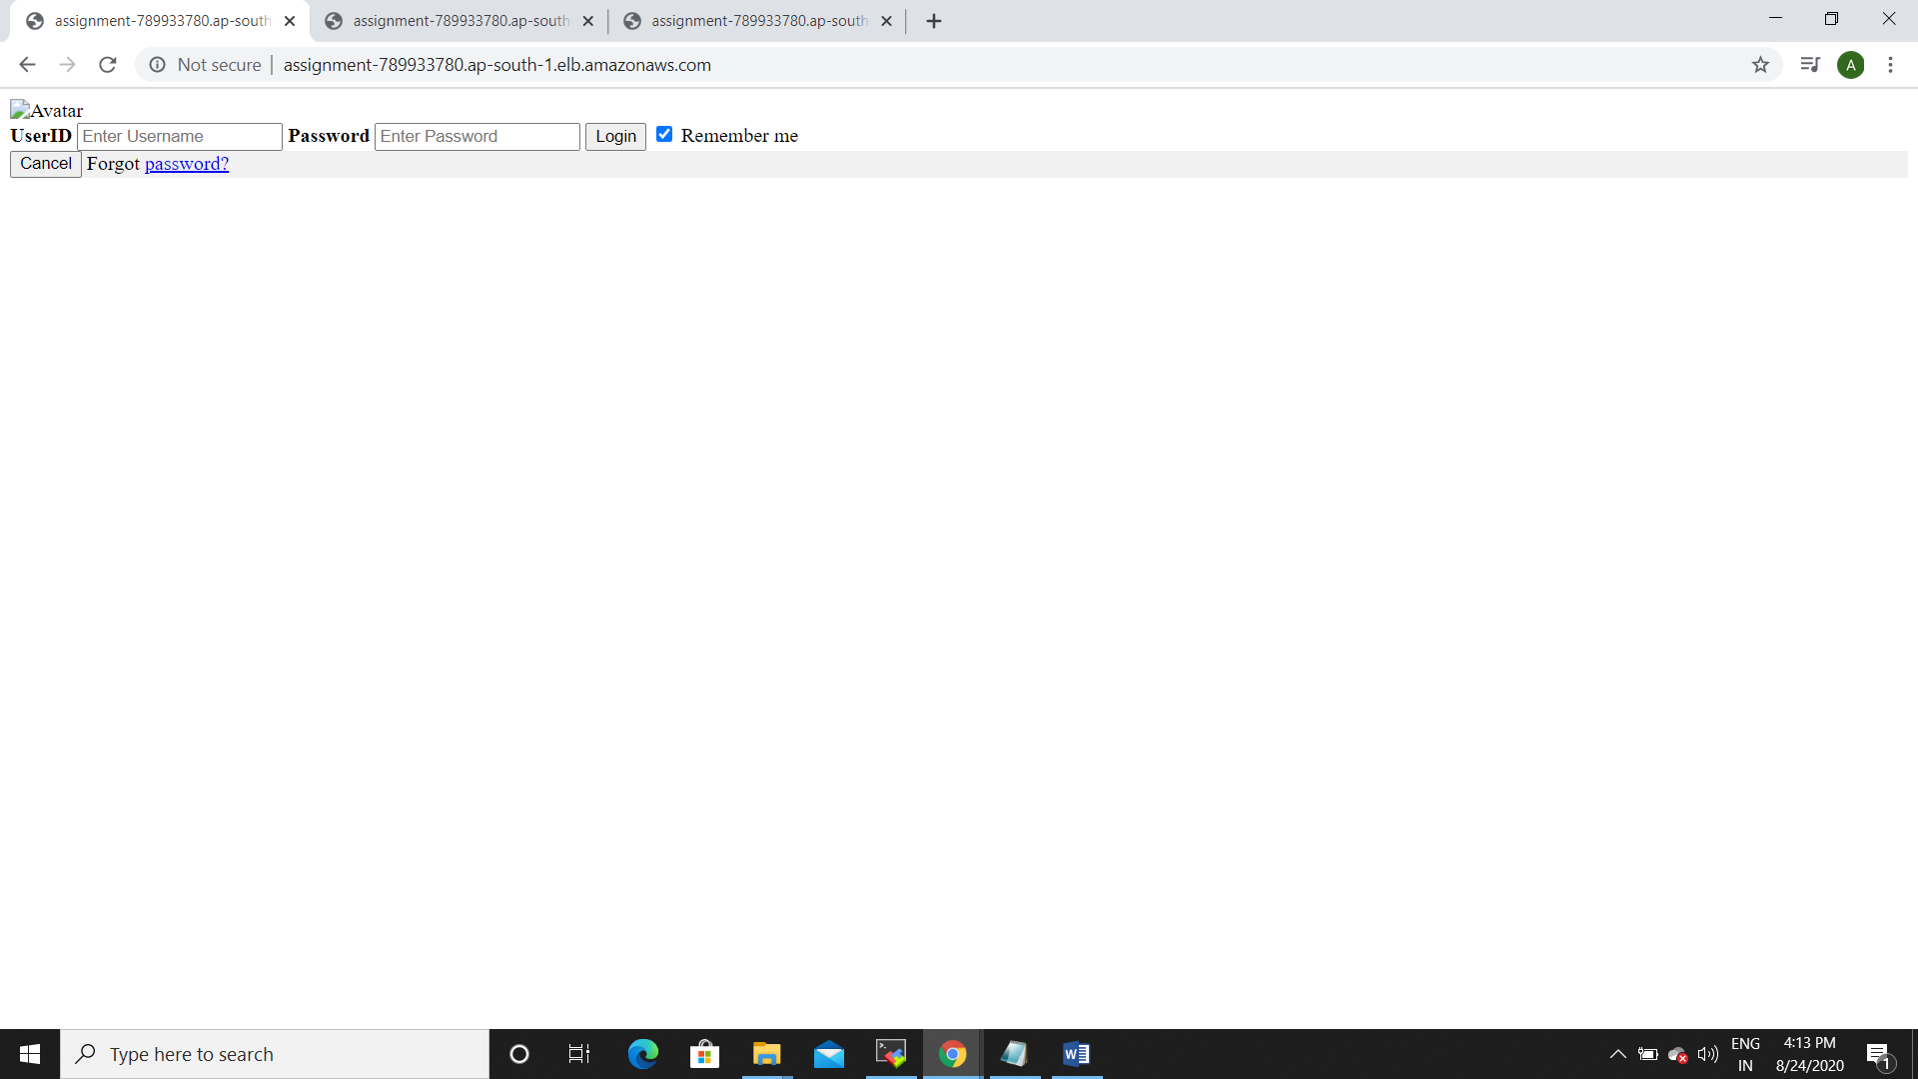

(DNS RESPONDING TO LINUX2)